Article

The GDP Illusion: How "Smart Money" Filters Economic Noise
In the high-stakes world of equity investing, there is a comforting logic that many investors cling to: If the economy is booming, the stock market must rise. It feels intuitive. If India’s GDP prints a massive growth number, surely it is time to buy the Nifty 50. Conversely, if economic growth stalls, it must be time to sell.
But a deep dive into the data from 2016 to 2025 reveals a startling truth. If you had invested based on this logic, your portfolio would likely be sluggish. The relationship between quarterly GDP growth and the Nifty 50 isn't just weak—it’s deceptive.
Here is the full story of the "Lag vs. Lead" disconnect, the dangerous loopholes in the narrative, and how smart money navigates the noise.

Part I: The Disconnect (Why GDP is not a Signal)

1. The Rearview Mirror Problem
Imagine driving a car on a winding highway while staring exclusively into the rearview mirror. You would know exactly where you’ve been, but you would be blind to the curve approaching in front of you.
This is the fundamental flaw of using GDP to time the market. GDP data is, by definition, backward-looking. When the government releases Q1 data, it tells us what happened in the previous three months.
The Stock Market (Nifty 50), however, is a forward-looking pricing mechanism. It is a discounting machine that prices in future expectations, not past glories. By the time a "record-breaking" GDP number flashes on the news tickers, the Nifty 50 has likely already priced that growth.

2. The Great Decoupling: The COVID Anomaly
There is no greater evidence of this disconnect than the chaos of 2020. This period serves as the ultimate cautionary tale for macro-investors.
The Nifty 50 didn't wait for the statisticians to confirm the damage; it did its crashing early. By the time the Q2 FY2020 GDP print actually arrived, the "blood in the streets" had already been priced in.
The Pre-Print Panic
In the lead-up to the announcement, the atmosphere was one of pure dread. The Nifty had already endured its violent correction as investors front-run the expected economic standstill. By the time the July–September window opened, the market had already digested the shock of the national lockdown.
The "Apocalyptic" Print
When the data finally dropped, it was a historic disaster: GDP had plummeted to -23.1%. On paper, the Indian economy had hit its darkest hour. This was the moment of truth for the "GDP Strategy" investor—the headlines were screaming for a total liquidation.
The Post-Print Paradox
Instead of a second collapse, the opposite happened. While the GDP print was a rearview mirror look at a locked-down past, the Nifty was already looking at a reopened future.
The Bottom: The panic had peaked before the news.
The Rally: After the print, the Nifty defied the "darkest hour" narrative, climbing from ~10,533 to ~11,794.
The Lesson: The market crashes on the fear of the print, but it often rallies on the certainty of the print, as it begins to price in the eventual recovery.

3. Valuation Over Headlines (2022–2024)
The lesson continued into the post-pandemic era. Between 2022 and 2024, India’s GDP growth stabilized into a predictable 4%–8% range. Yet, the Nifty 50 went parabolic, shattering the 20,000 and 22,000 barriers.
This rally wasn't driven by GDP shocks; it was driven by PE (Price-to-Earnings) expansion and robust corporate profitability. The market proved that stocks can offer massive returns even if GDP growth is merely "average," provided companies are becoming more efficient.

Part II: The Reality Check (The Loopholes)
While the "ignore GDP" narrative is powerful for short-term trading, a well-rounded investor must understand the risks. There are three critical "loopholes" where ignoring the economy can be dangerous.

1. The "Nifty ≠ Economy" Loophole
The Nifty 50 is not a perfect mirror of the Indian domestic economy. It is a globalized index.
- The Global Factor: Giants like TCS and Infosys depend on US and European GDP, not India’s. If the US enters a recession, the Nifty suffers, even if India’s domestic consumption is booming.
- Commodities: Reliance and Tata Steel react to global oil and metal prices, which often move independently of Indian GDP.

2. The "Liquidity Illusion"
We cannot attribute the 2020 market rally solely to "optimism." The loophole here is Central Bank Intervention.
The market disconnected from the crashing GDP largely because the system was flooded with cheap money (liquidity) and record-low interest rates. When money is low cost, it chases assets like stocks. If you remove the liquidity, the "forward-looking" market might have looked much uglier.

3. The Gravity of Valuation (Buffett Indicator)
You can ignore GDP for a quarter, but you cannot decouple from it forever.
The Market Cap to GDP Ratio is a mean-reverting metric. If stock prices grow at 15% while the economy grows at only 6% for a decade, a bubble forms. Eventually, the market must correct to realign with economic reality. Ignoring GDP when valuations are at historic highs is not "structural investing"—it is gambling.

Summary: The Investor's Cheat Sheet
To clarify the strategy, here is a comparison of how different factors influence the Nifty vs. GDP.
Feature | Quarterly GDP Data | Nifty 50 Movement | The Insight
Time Horizon | Backward-Looking (Past 3 Months) | Forward-Looking (Next 6-9 Months) | Market moves on future earnings, not past growth.
Primary Driver | Domestic Consumption & Govt Spending | Liquidity, Global Sentiment, Corporate Earnings | A booming economy doesn't always mean booming profits.
Inflation Impact | Adjusted for Inflation (Real GDP) | Not Adjusted (Nominal Prices) | Stocks can rise purely due to inflation (Nominal growth).
Crisis Correlation | Drops significantly (e.g., -23% in 2020) | Often Rises ("Climbing the Wall of Worry") | Bad economic news often marks the market bottom.
Long-Term Link | The "floor" of the economy. | The "ceiling" of valuation. | Over decades, they converge. Short term, they diverge.

The Final Verdict: Anticipate, Don't React
So, can you invest in the Nifty 50 based on Quarterly GDP Growth Rates?
Short Answer: No.
Long Answer: No, but you must respect the trend.
The data suggests a nuanced approach for the intelligent investor:
- Stop Trading the News: Do not let a single quarter of weak GDP data scare you out of your position. History shows the market often bottoms out exactly when the economic headlines look their worst.
- Watch the Liquidity, Not Just Growth: The Nifty is often more correlated with interest rates and global liquidity than it is with domestic manufacturing output.
- Respect the Gravity: While you should ignore quarterly blips, keep an eye on the long-term Market Cap to GDP ratio. If the market runs too far ahead of the economy for too long, a correction is inevitable.
In the end, GDP tells you the history of the nation. The Nifty tells you the future of its corporations. To make money, keep your eyes on the road ahead, but check your dashboard (valuations) occasionally to ensure you aren't overheating.
Disclaimer: The content should not be construed as investment, trading, or personal financial advice.This blog is for educational purposes only.
Source: Trading economics, Trading view

Graph Data
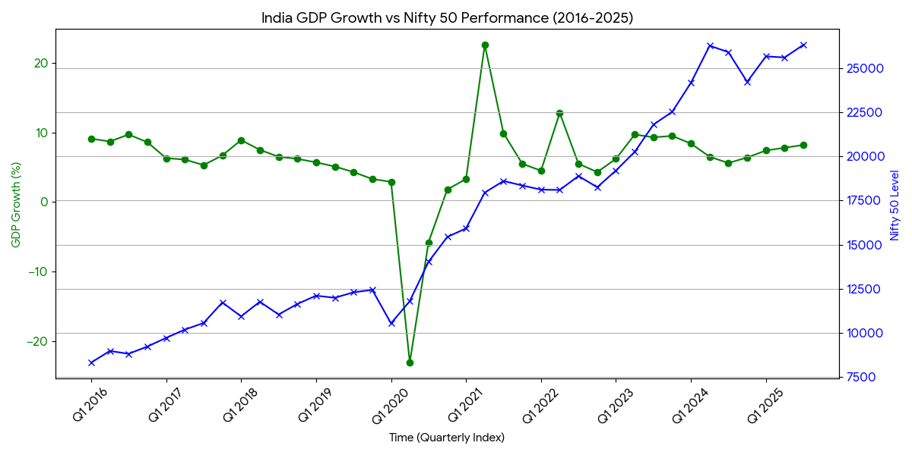

Indian |  |  |  | US
FY | FY | FY |  | Calendra | Calendra | Calendra
Month | Quarter | Year | GDP % | Nifty | Year | Month
Apr-Jun | Q1 | 2016 | 9.1 | 8,308.15 | 2016 | Apr-Jun
Jul-Sep | Q2 | 2016 | 8.7 | 8,968.70 | 2016 | Jul-Sep
Oct-Dec | Q3 | 2016 | 9.7 | 8,806.95 | 2016 | Oct-Dec
Jan-Mar | Q4 | 2016 | 8.6 | 9,218.40 | 2016 | Jan-Mar
Apr-Jun | Q1 | 2017 | 6.3 | 9,709.30 | 2017 | Apr-Jun
Jul-Sep | Q2 | 2017 | 6.1 | 10,178.95 | 2017 | Jul-Sep
Oct-Dec | Q3 | 2017 | 5.3 | 10,552.40 | 2017 | Oct-Dec
Jan-Mar | Q4 | 2017 | 6.7 | 11,717.55 | 2017 | Jan-Mar
Apr-Jun | Q1 | 2018 | 8.9 | 10,929.20 | 2018 | Apr-Jun
Jul-Sep | Q2 | 2018 | 7.5 | 11,760.20 | 2018 | Jul-Sep
Oct-Dec | Q3 | 2018 | 6.5 | 11,035.65 | 2018 | Oct-Dec
Jan-Mar | Q4 | 2018 | 6.2 | 11,630.35 | 2018 | Jan-Mar
Apr-Jun | Q1 | 2019 | 5.7 | 12,103.05 | 2019 | Apr-Jun
Jul-Sep | Q2 | 2019 | 5.1 | 11,981.75 | 2019 | Jul-Sep
Oct-Dec | Q3 | 2019 | 4.3 | 12,293.90 | 2019 | Oct-Dec
Jan-Mar | Q4 | 2019 | 3.3 | 12,430.50 | 2019 | Jan-Mar
Apr-Jun | Q1 | 2020 | 2.9 | 10,533.15 | 2020 | Apr-Jun
Jul-Sep | Q2 | 2020 | -23.1 | 11,794.25 | 2020 | Jul-Sep
Oct-Dec | Q3 | 2020 | -5.8 | 14,024.85 | 2020 | Oct-Dec
Jan-Mar | Q4 | 2020 | 1.8 | 15,431.75 | 2020 | Jan-Mar
Apr-Jun | Q1 | 2021 | 3.3 | 15,915.65 | 2021 | Apr-Jun
Jul-Sep | Q2 | 2021 | 22.6 | 17,947.65 | 2021 | Jul-Sep
Oct-Dec | Q3 | 2021 | 9.9 | 18,604.45 | 2021 | Oct-Dec
Jan-Mar | Q4 | 2021 | 5.5 | 18,350.95 | 2021 | Jan-Mar
Apr-Jun | Q1 | 2022 | 4.5 | 18,114.65 | 2022 | Apr-Jun
Jul-Sep | Q2 | 2022 | 12.8 | 18,096.15 | 2022 | Jul-Sep
Oct-Dec | Q3 | 2022 | 5.5 | 18,887.60 | 2022 | Oct-Dec
Jan-Mar | Q4 | 2022 | 4.3 | 18,251.95 | 2022 | Jan-Mar
Apr-Jun | Q1 | 2023 | 6.2 | 19,201.70 | 2023 | Apr-Jun
Jul-Sep | Q2 | 2023 | 9.7 | 20,255.70 | 2023 | Jul-Sep
Oct-Dec | Q3 | 2023 | 9.3 | 21,801.45 | 2023 | Oct-Dec
Jan-Mar | Q4 | 2023 | 9.5 | 22,526.60 | 2023 | Jan-Mar
Apr-Jun | Q1 | 2024 | 8.4 | 24,174 | 2024 | Apr-Jun
Jul-Sep | Q2 | 2024 | 6.5 | 26,277.35 | 2024 | Jul-Sep
Oct-Dec | Q3 | 2024 | 5.6 | 25,907.60 | 2024 | Oct-Dec
Jan-Mar | Q4 | 2024 | 6.4 | 24,226.70 | 2024 | Jan-Mar
Apr-Jun | Q1 | 2025 | 7.4 | 25,669.35 | 2025 | Apr-Jun
Jul-Sep | Q2 | 2025 | 7.8 | 25,608.10 | 2025 | Jul-Sep
Oct-Dec | Q3 | 2025 | 8.2 | 26,325.80 | 2025 | Oct-Dec
Jan-Mar | Q4 | 2025 |  |  | 2025 | Jan-Mar

